# Experimental build instructions

9/2/2025

This experimental configuration uses a TIP120, 8.2 Ohm Resistor and a Revised Main Body (A) part for higher sensitivity and accuracy measurements. Build the DIYNAFLUOR as per the Base build instructions, with the following alternative wiring schematic and parts.

Note: For builders with limited electrical engineering experience, it is recommended that this Experimental build is only attempted after the Base DIYNAFLUOR has been attempted and verified.

**Parts Required: Base DIYNAFLUOR BoM + The following additional parts.**

|  |  |
| --- | --- |
| **Part** | **Link** |
| TIP120 - TRANS NPN DARL 60V 5A TO-220 | [Link](https://www.digikey.com.au/en/products/detail/stmicroelectronics/TIP120/603564?so=90703501&content=productdetail_AU&mkt_tok=MDI4LVNYSy01MDcAAAGYNQyxqsRdJyh5G26PQ70QkTAawQtXGiZzqs7sSC3Vasdfto5ZCqXL_9Qc6pOmka4CzjMmD1xFlP0Ke5eODOrxNfhtdj9KbJqMDO-AC7gn) |
| RES 8.2 OHM 5% 2W AXIAL | [Link](https://www.digikey.com.au/en/products/detail/vishay-beyschlag-draloric-bc-components/PR02000208208JR500/596237?so=90703501&content=productdetail_AU&mkt_tok=MDI4LVNYSy01MDcAAAGYNQyxqg167KwkEpcK79wzFAdiugabRs-si4hp4SkPH9fSpKJbe3CBNXAfg9RkuengPs9aFVtKN12VqVp3oYm5--XA7mL4eZezFvatMgti) |
| Through Hole Resistor, 2.2 kohm, ROX Series, 2 W | [Link](https://au.element14.com/neohm-te-connectivity/rox2sj2k2/res-2k2-5-2w-axial-metal-oxide/dp/1738643?CMP=e-email-sys-orderack-GLB) |
| 2 X  1 x F-F hookup cable (10 cm) | [Link](https://www.ebay.com.au/itm/196101531443) |
| 1 x Main Body (A) Experimental | See Experimental Folder for STL file |

Note: the 68 Ohm resistor in the base DIYNAFLUOR build is not used.

**IMPROTANT:** The Main Body (A) Experimental part requires the excitation and emission holes to be drilled out with a 3 mm drill-bit prior to assembly. Do not drill through to the other side of the sample chamber.

**Wiring schematic:**

Mount the TIP120 onto the Filer Cube during assembly by bolting it in place at the shown position. (This uses the upper nut and bolt assembly that holds part A and B together).

Tip: Mount the TIP120 at an angle to allow room for the JST connector port.

Once the JST cable is inserted, rotate the TIP120 to a horizontal position.

Below shows the correct wiring configuration for the Experimental Tip120 design.

Note: Both resistor wires have been cut to ~ 10 mm, as per the 68 Ohm resistor in the base build.

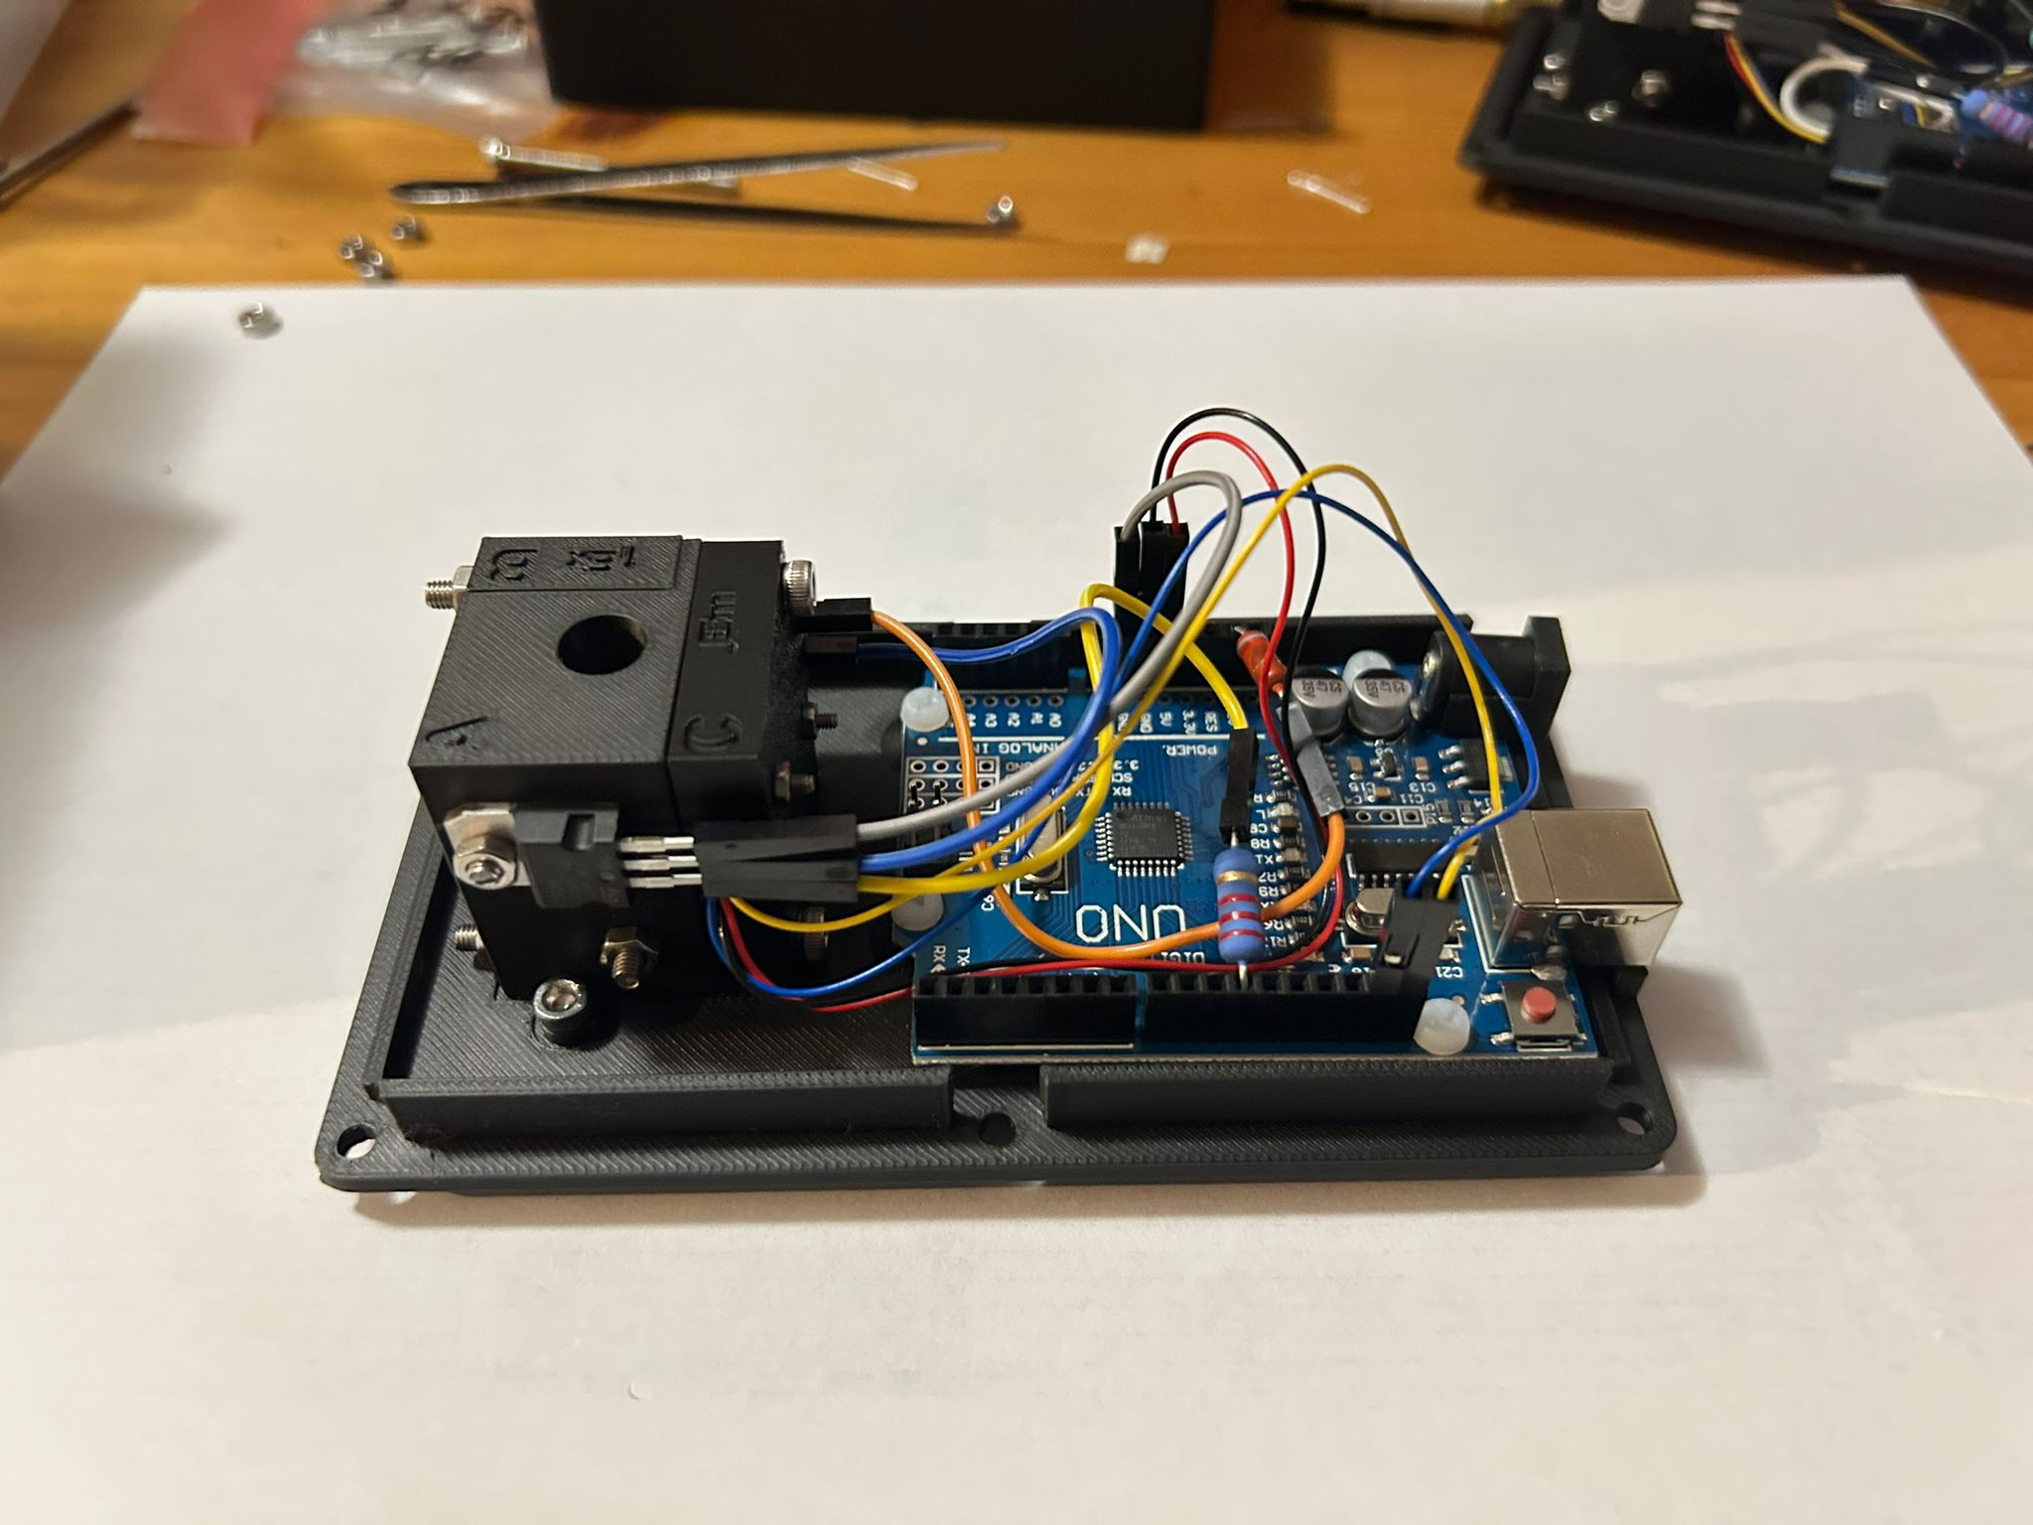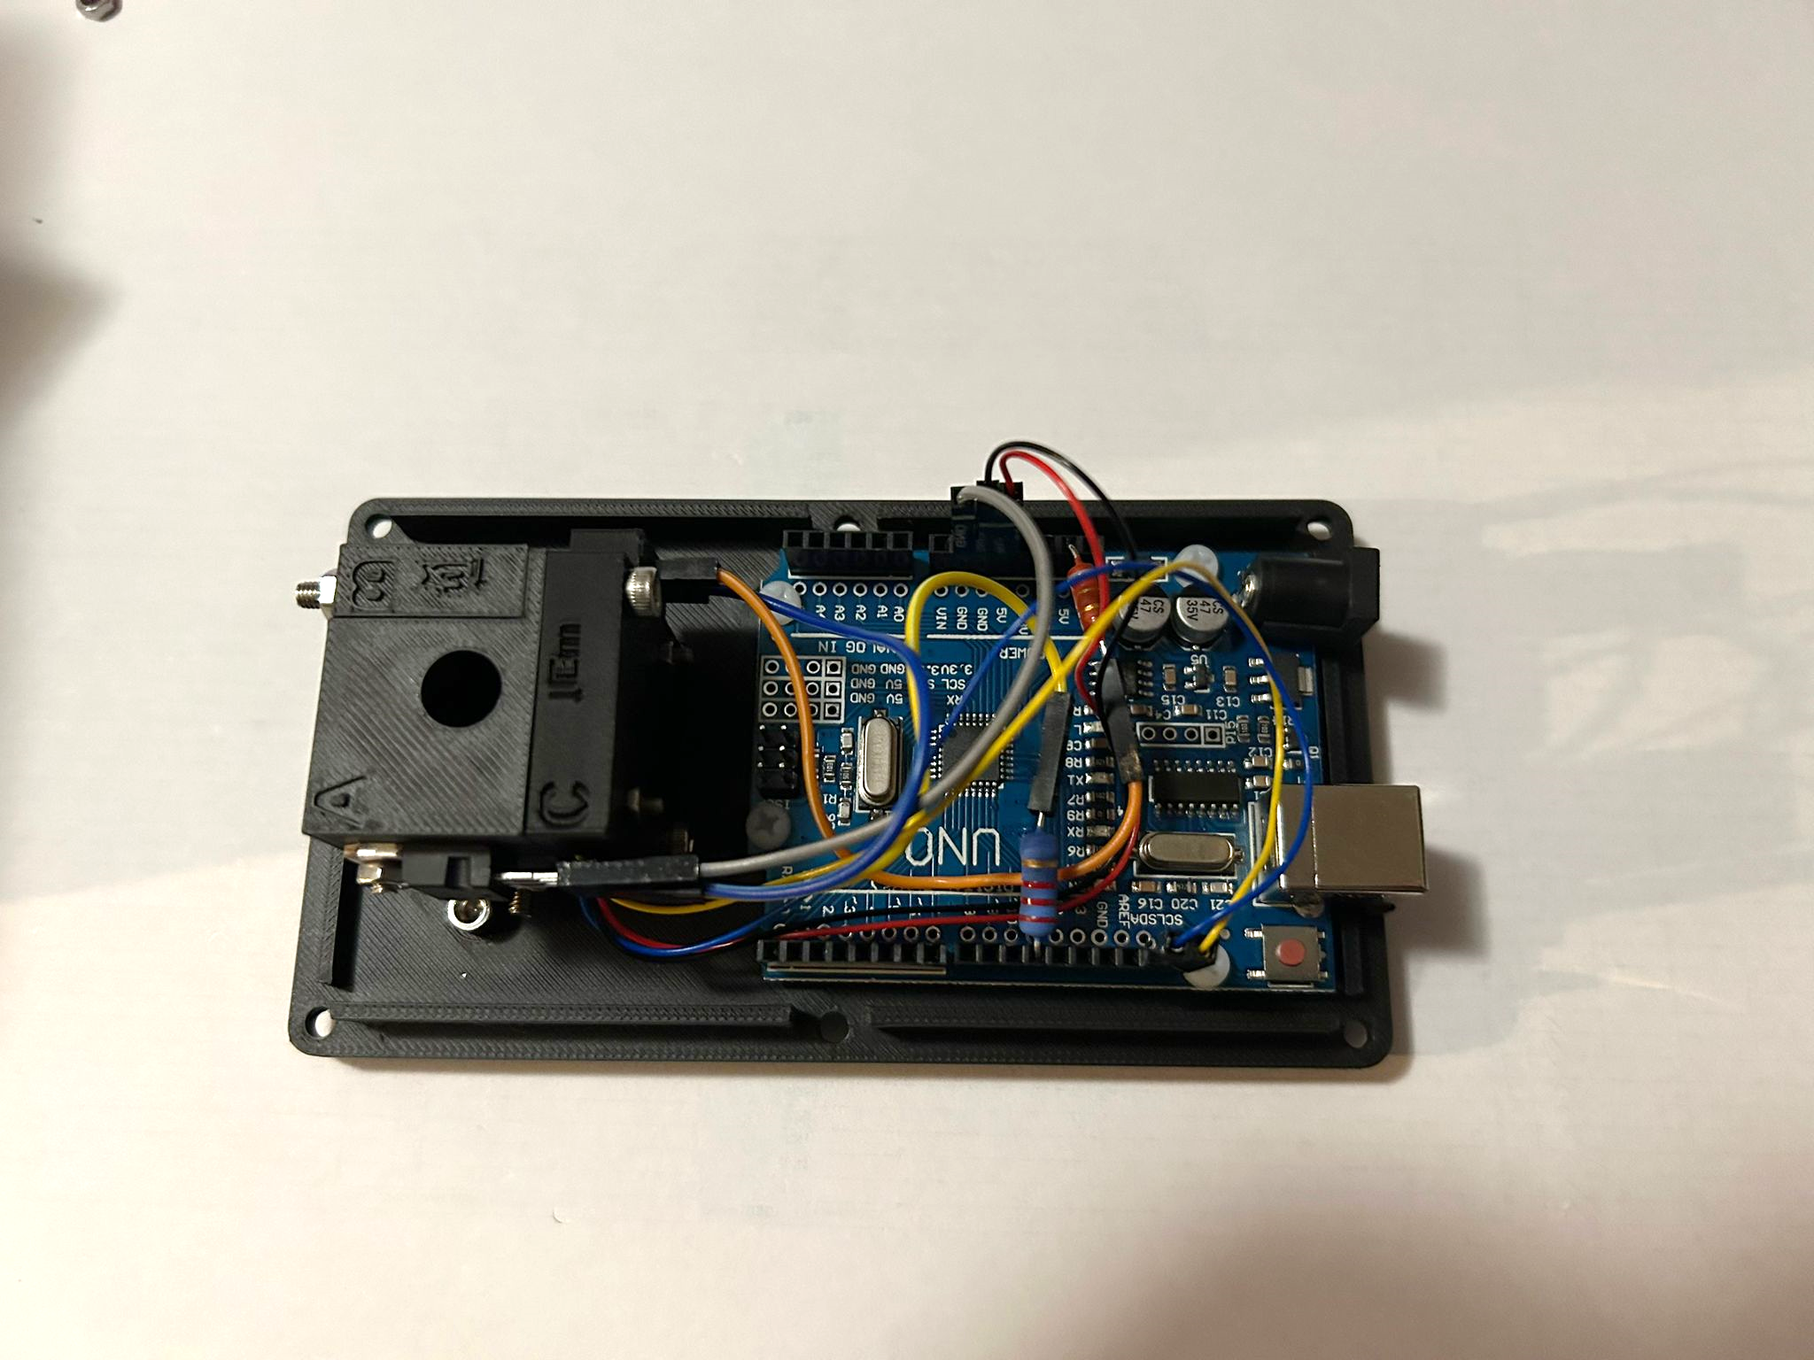

If you have any issues or interesting observations with this Experimental build, please contact [w.anderson1@uq.edu.au](mailto:w.anderson1@uq.edu.au), or leave an issue on our GitHub repo. <https://github.com/traulab/DIYNAFLUOR>